**Welcome to the 4th Epping Forest South Sea Scouts**

**Chief Scout Gold Award Programme**

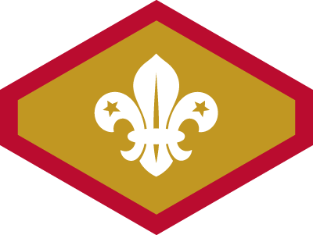

We aim to get all our Scouts through the Chief Scout Gold Award if they elect to stay with the troop for the full three years. Scouts attending the majority of Thursday evenings sessions, Summer camps as well as our Water Activities sessions at Fairlop Waters will get through most of the requirements of the award, but some independent work is also required.

This letter explains how your leaders will provide a framework to help you manage the independent work, but it can be carried out at any time. The full details of the award requirements can be found on the main Scouts website [www.scouts.org.uk](http://www.scouts.org.uk) and also on the 4th EFS website (see links in covering email).

**Challenge Awards**

|  |  |
| --- | --- |
| The core element of the Gold Award is the requirement to complete the 9 Challenge Awards.  Many of the award elements are covered by our Thursday evening programme but some elements will need to be undertaken independently.  Four of these are listed below. They can be undertaken at any point but we would recommend getting these signed off as soon as possible. These are:   1. Additional Activity Badges; 2. Adventurous Activities; 3. Creative Activities; 4. Taking part in a performance. | C:\Users\David\AppData\Local\Microsoft\Windows\INetCache\Content.Word\Challenge Badges.jpg |

Don’t worry if these elements are not all completed within the first year with the troop, they can carry across to next year as well.

**Additional Independent Activities - Year One**

We will soon send some additional activities that should be completed within the first year with the troop. Don’t worry they are not difficult and usually can easily be completed either at school or other clubs.

*If you want to complete any of the Challenge Award elements download the relevant self completion Pro Forma from the 4th EFS website and get it signed off.*

**Activity and Staged Badges**

There are also a great many activity and staged badges Scouts can complete.

Details on how to complete each badge on the Scouts website www.scouts.org.uk

The lower stages of some of the 'staged' badges are completed during Thursday evening sessions (Swimmer, Time on Water, Emergency Aid, Nautical Skills, Paddle Sports, Sailing) but if these badges cover an area of deep interest please speak to a Scout leader about the higher stages.

**Who can sign off Activity and Challenge Badges?**

This depends on the badge. Usually it will be another adult such as a teacher at school or a club sports coach. Sometimes parents may be allowed to sign off activities, but usually it needs to be an independent adult. Speak to Scout Leaders before starting any activity.

**Further down the line…………..**

In their second and third year with the troop Scouts will be given other activities to complete. In the third year Scouts will also need to undertake other activities such as an Expedition and Environmental project, which the leaders will organise.